## 

## **Experiment-9**

**Student Name:** Gauri Prabhakar **UID:** 18BCS6201

**Branch:** 18AITAIML-2 **Section/Group:** B

**Semester:** 7 **Date of Performance:** 17h November, 2021

**Subject Name:** Advanced Database Management Lab **Subject Code:** CSP - 434

# Aim/Overview of the practical:

To implement a Case Study explaining the need for converting tables to fourth and fifth Normal forms.

# Task to be done:

To implement a Case Study explaining the need for converting tables to fourth and fifth Normal forms.

1. What is 4NF and 5NF?

**A table is said to be in 4NF iff:**

* It is in BCNF.
* It is independent of many to one relationships and multi-valued attributes.

**A table is said to be in 5NF iff:**

* It is in 4NF.
* It is independent of any join dependency.
* It is broken into as many tables as possible.

1. **Why 4NF?**

* 4NF helps reduce redundancy.
* Helps avoid contradiction.

1. **Why 5NF?**

* 5NF helps reduce redundancy.
* Helps avoid update anomalies.

# Steps to be followed:

**4NF:**

**Creating a table CANDIDATE which does not follow 4NF norms and then returning it, then creating another table CAND_OCC to eliminate multi-valued attributes:**

# CREATE TABLE CANDIDATE(Adhaar int, Occupation varchar(50), Specialization varchar(50));

# INSERT INTO CANDIDATE VALUES( 1001, 'Student', 'AIML');

# INSERT INTO CANDIDATE VALUES( 1001, 'Teacher', 'IOT');

# INSERT INTO CANDIDATE VALUES( 1002, 'Engineer', 'AIML');

# INSERT INTO CANDIDATE VALUES( 1002, 'Trainee', 'IOT');

# SELECT * FROM CANDIDATE;

CREATE TABLE CAND_OCC(Adhaar int, Occupation varchar(50));

INSERT INTO CAND_OCC(Adhaar, Occupation) SELECT DISTINCT Adhaar, Occupation FROM CANDIDATE;

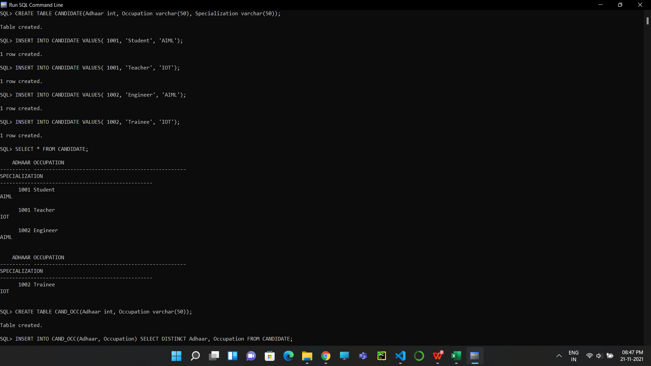

**Creating another table CAND_SPEC to eliminate multi-valued attributes then returning both the tables:**

1. CREATE TABLE CAND_SPEC(Adhaar int, Specialization varchar(50));

INSERT INTO CAND_SPEC(Adhaar, Specialization) SELECT DISTINCT Adhaar, Specialization FROM CANDIDATE;

SELECT * FROM CAND_OCC;

SELECT * FROM CAND_SPEC;

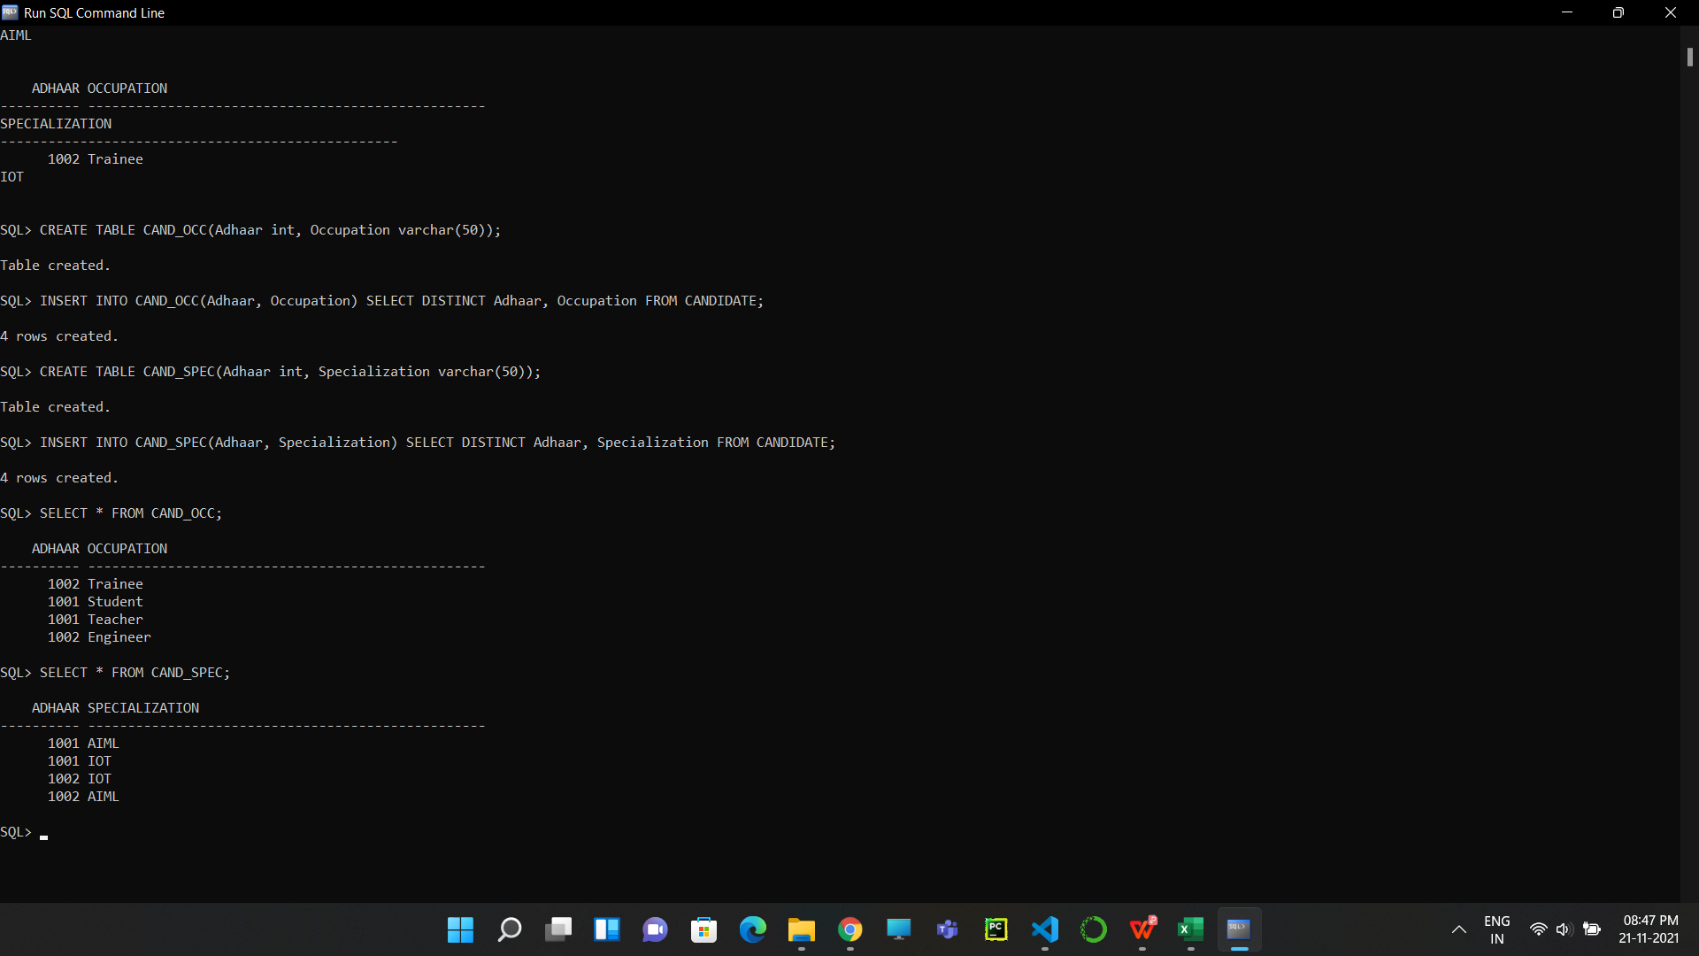

**Output:**

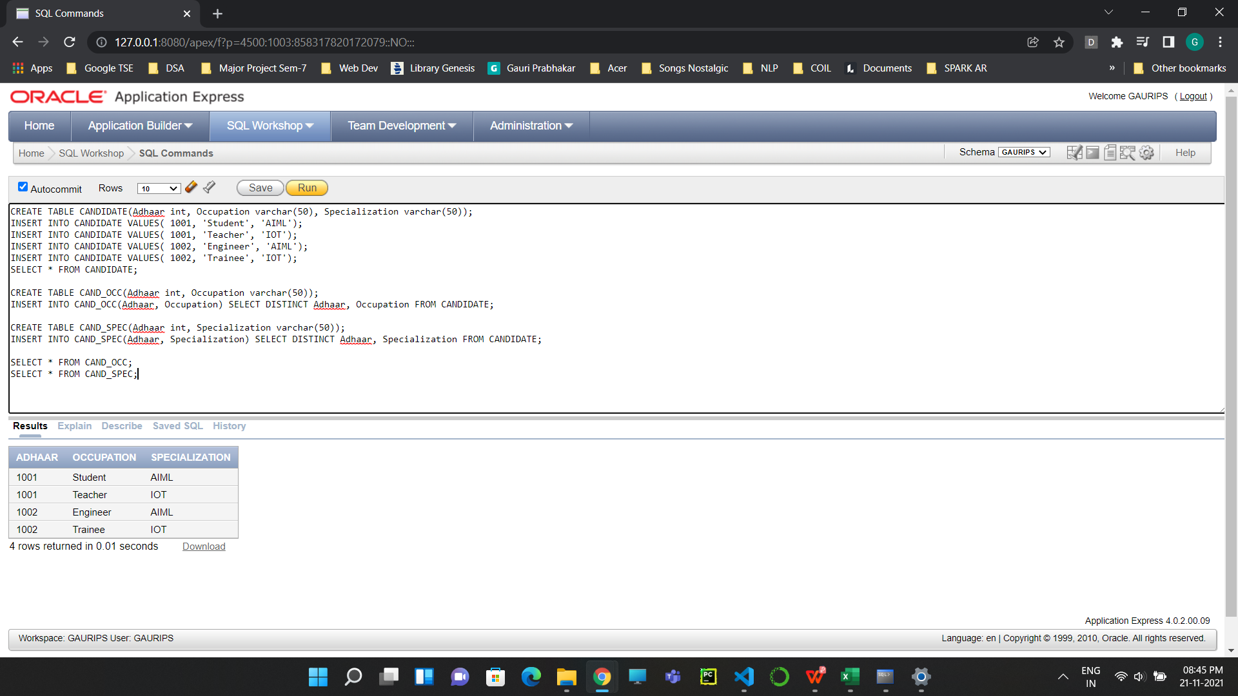

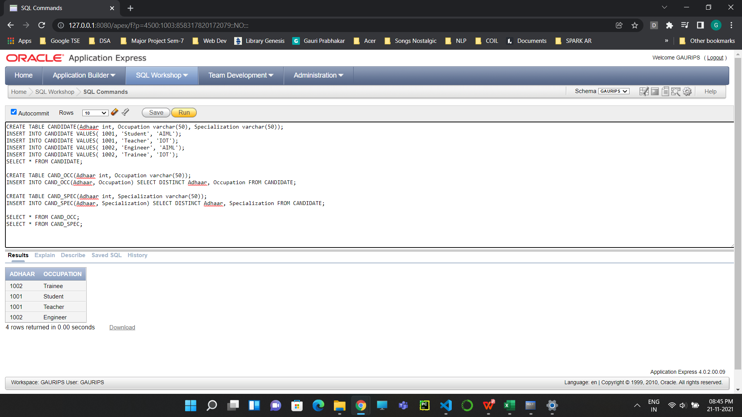

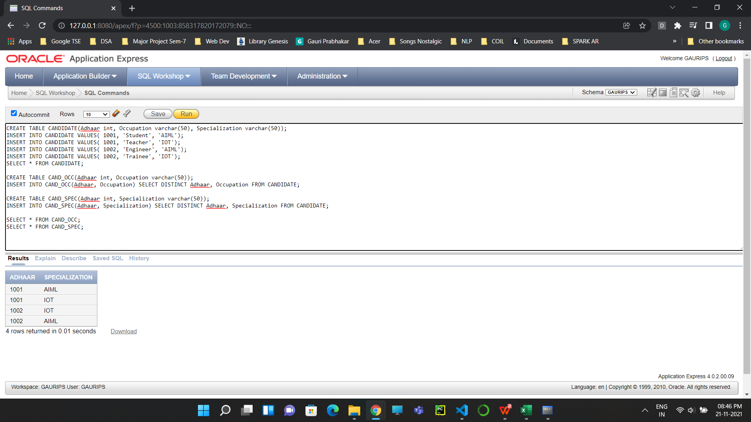

**Now the table is in 4NF.**

**5NF:**

**Creating table SEMESTER which does not follow 5NF and then returning it:**

1. CREATE TABLE SEMESTER(Subject varchar(50), Lecturer varchar(50), Semester int);

INSERT INTO SEMESTER VALUES('AIML', 'Chandler', 1);

INSERT INTO SEMESTER VALUES('AIML', 'Ross', 1);

INSERT INTO SEMESTER VALUES('IOT', 'Ross', 1);

INSERT INTO SEMESTER VALUES('IOT', 'Monica', 2);

INSERT INTO SEMESTER VALUES('CLOUD', 'Rachel', 1);

SELECT * FROM SEMESTER;

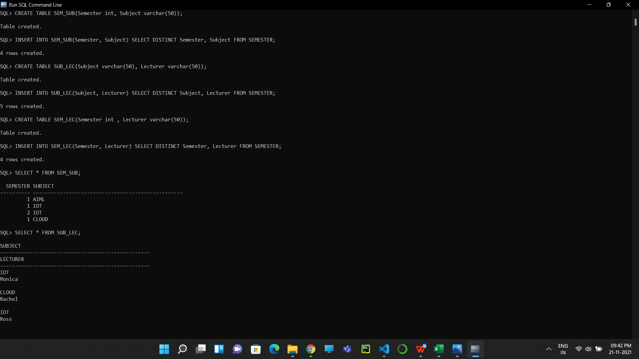

**Creating 3 tables, SEM_SUB, SUB_LEC and SEM_LEC to convert the above table to 5NF and then returning them:**

1. CREATE TABLE SEM_SUB(Semester int, Subject varchar(50));

INSERT INTO SEM_SUB(Semester, Subject) SELECT DISTINCT Semester, Subject FROM SEMESTER;

CREATE TABLE SUB_LEC(Subject varchar(50), Lecturer varchar(50));

INSERT INTO SUB_LEC(Subject, Lecturer) SELECT DISTINCT Subject, Lecturer FROM SEMESTER;

CREATE TABLE SEM_LEC(Semester int , Lecturer varchar(50));

INSERT INTO SEM_LEC(Semester, Lecturer) SELECT DISTINCT Semester, Lecturer FROM SEMESTER;

SELECT * FROM SEM_SUB;

SELECT * FROM SUB_LEC;

SELECT * FROM SEM_LEC;



**Output:**

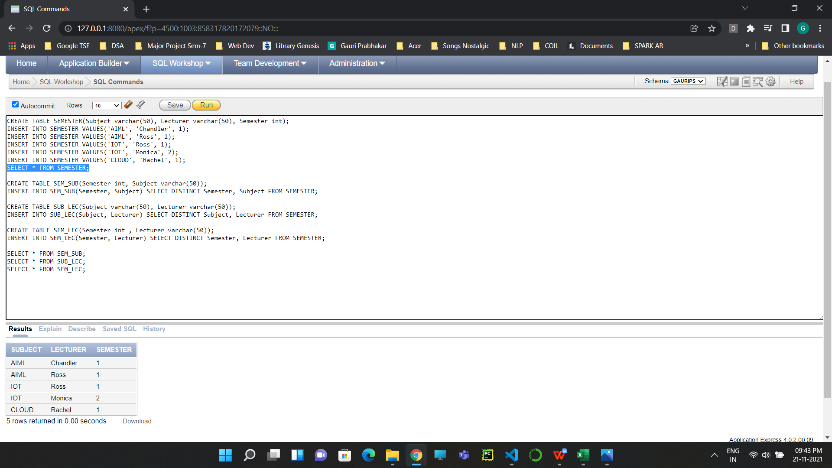



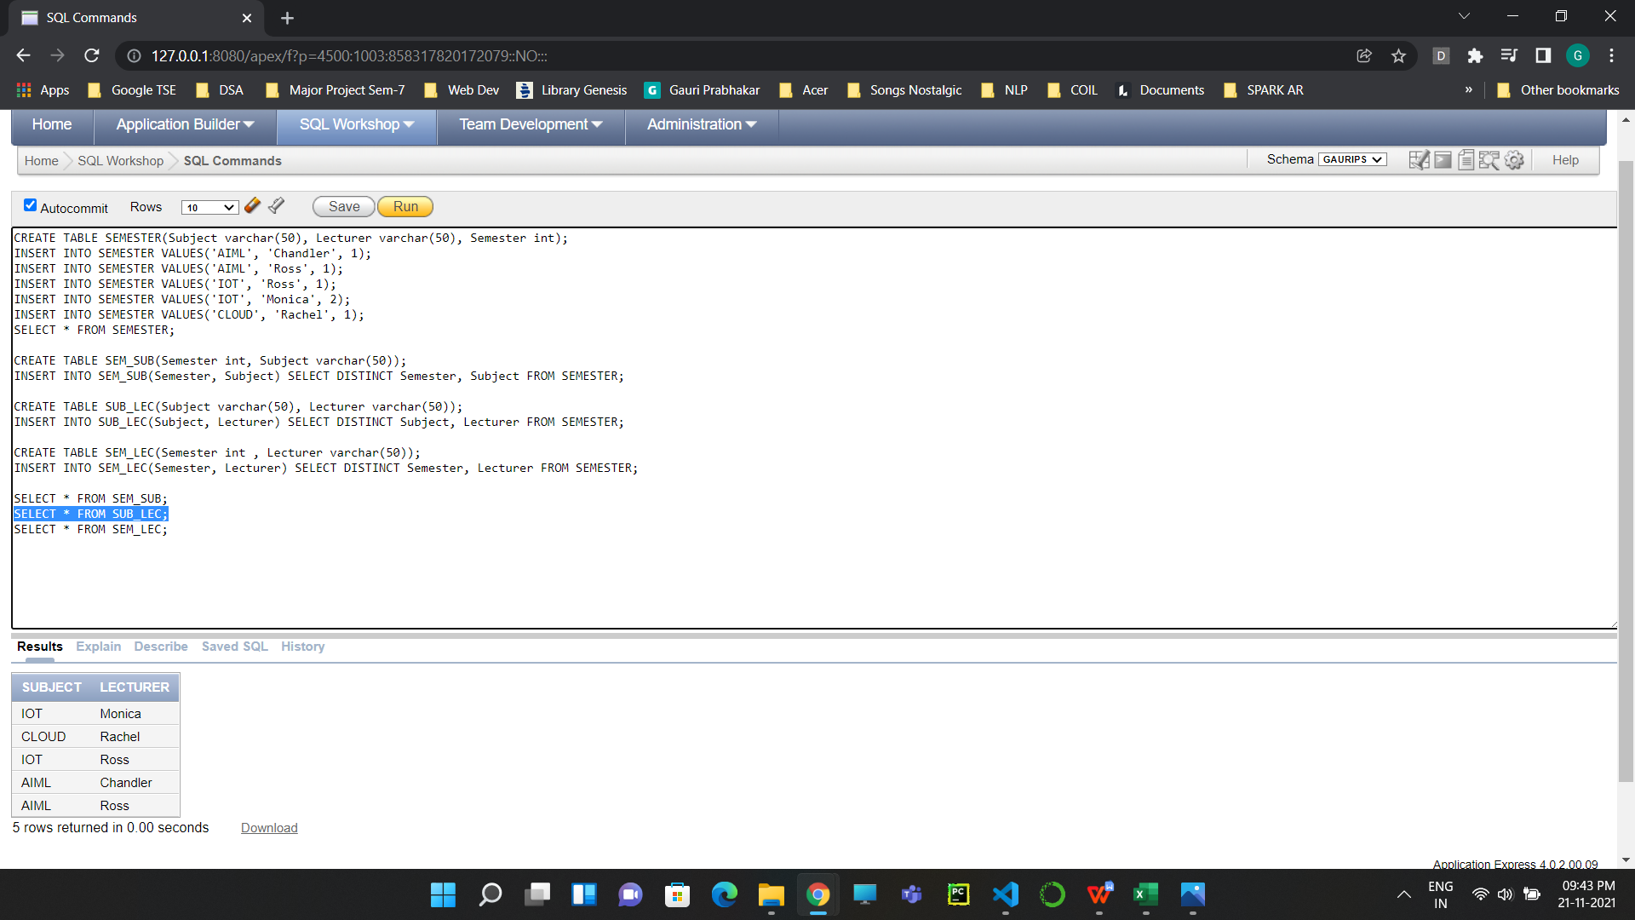

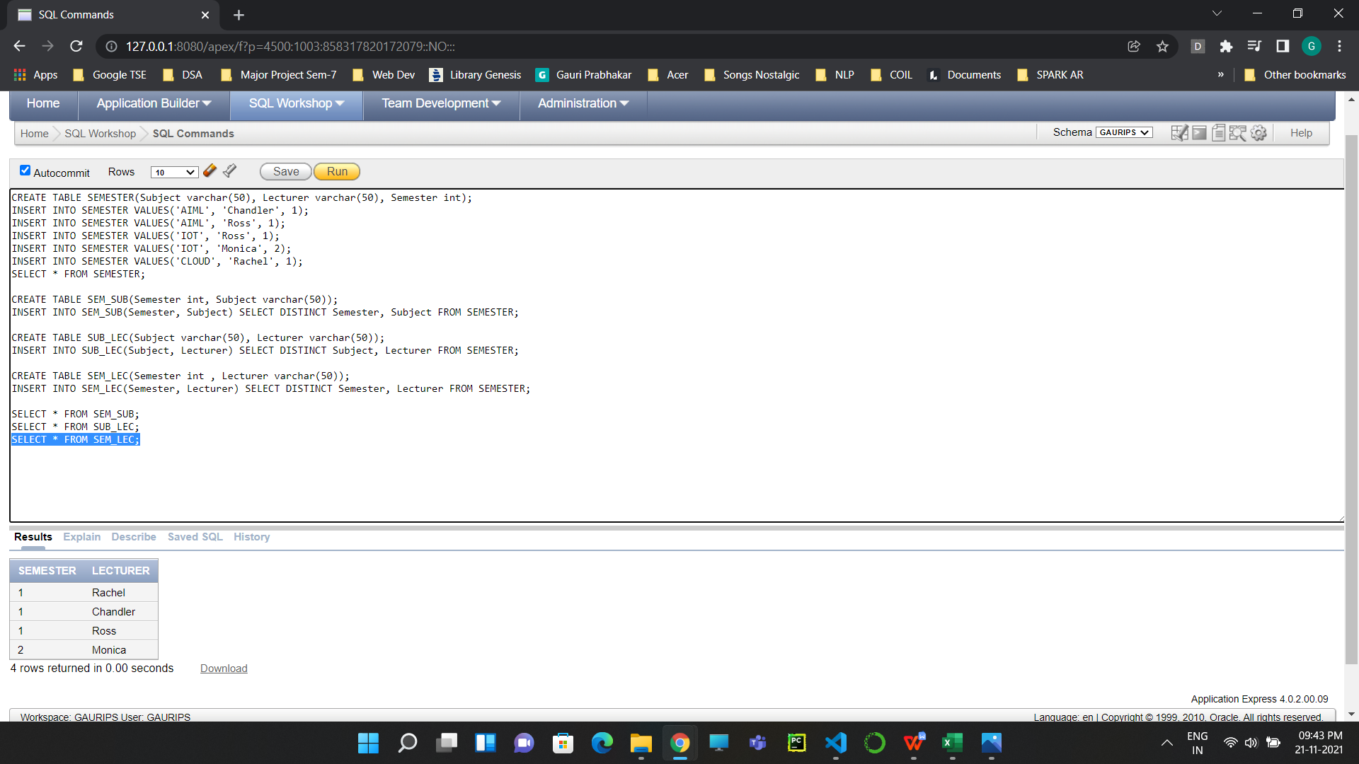

**Now the table is in 5NF.**

1. **Result/Output/Writing Summary:**

* Successfully implemented table conversion to 4NF.
* Successfully implemented table conversion to 5NF.
* Successfully implemented operations for NORMALIZATION.
* Successfully understood the functioning and importance of the above mentioned.

# Learning outcomes (What I have learnt):

* How to implement table conversion to 4NF on SQL Command Line.
* How to implement table conversion to 5NF on SQL Command Line.
* How to implement NORMALIZATION on a table.

**Evaluation Grid (To be created as per the SOP and Assessment guidelines by the faculty):**

|  |  |  |  |
| --- | --- | --- | --- |
| Sr. No. | Parameters | Marks Obtained | Maximum Marks |
| 1. |  |  |  |
| 2. |  |  |  |
| 3. |  |  |  |